Important note: we have Minneapolis gunshot reports spanning 2007 to present day in 2020. But MPD has apparently stripped this dataset and the data powering the city’s gunfire map of all dispositions. Our original 2018 dataset we were working with contains them. So we may need to make a data request for a version of the 2007-2020 dataset that contains dispositions to get a more accurate portrayal of what happens when a gunfire incident is reported, by either 9-11 or ShotSpotter.

Some takeaways from what we do have:

* Gunshots in Minneapolis are overwhelmingly reported in North Minneapolis neighborhoods, and sometimes around Central Minneapolis and Longfellow.
* These areas tend to be more ethnically/racially diverse, younger and lower-income.
* Reported gunshots are more likely to occur between the hours of 10pm and 3am on Saturdays and Sundays.
* About 60% of shots fired reports were generated by people making 9/11 calls between 2015 and 2020. About 35% were triggered by ShotSpotter activations.
* Only about a quarter of reported gunfire incidents were rooted in a verifiable shooting throughout 2018/2019.
* Most reported gunshots don’t lead to anything happening. About 66% of ShotSpotter incidents in 2018 were either false positives, canceled calls or cleared scenes upon arrival by officers. A similar portion – about 70% – represented gunshot reports initiated by 9-11 calls or officers themselves.

**24,000 SHOTS FIRED REPORTS BY CENSUS TRACT, 2015-2020**

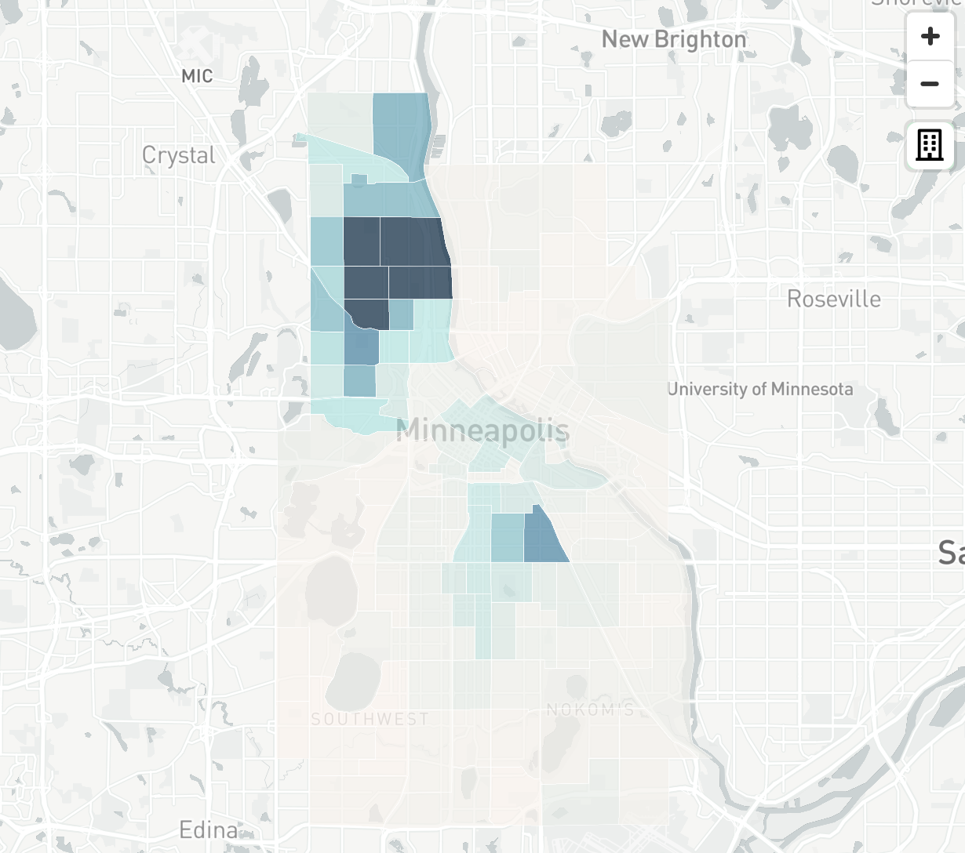

[**EXPLORE THIS**](http://static.startribune.com/news/projects/all/20200504-shots/)

**MEDIAN INCOME BY CENSUS TRACT, 2018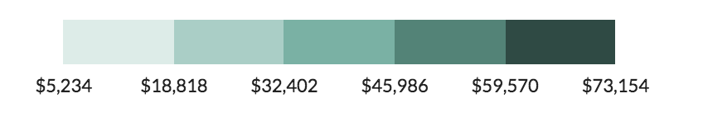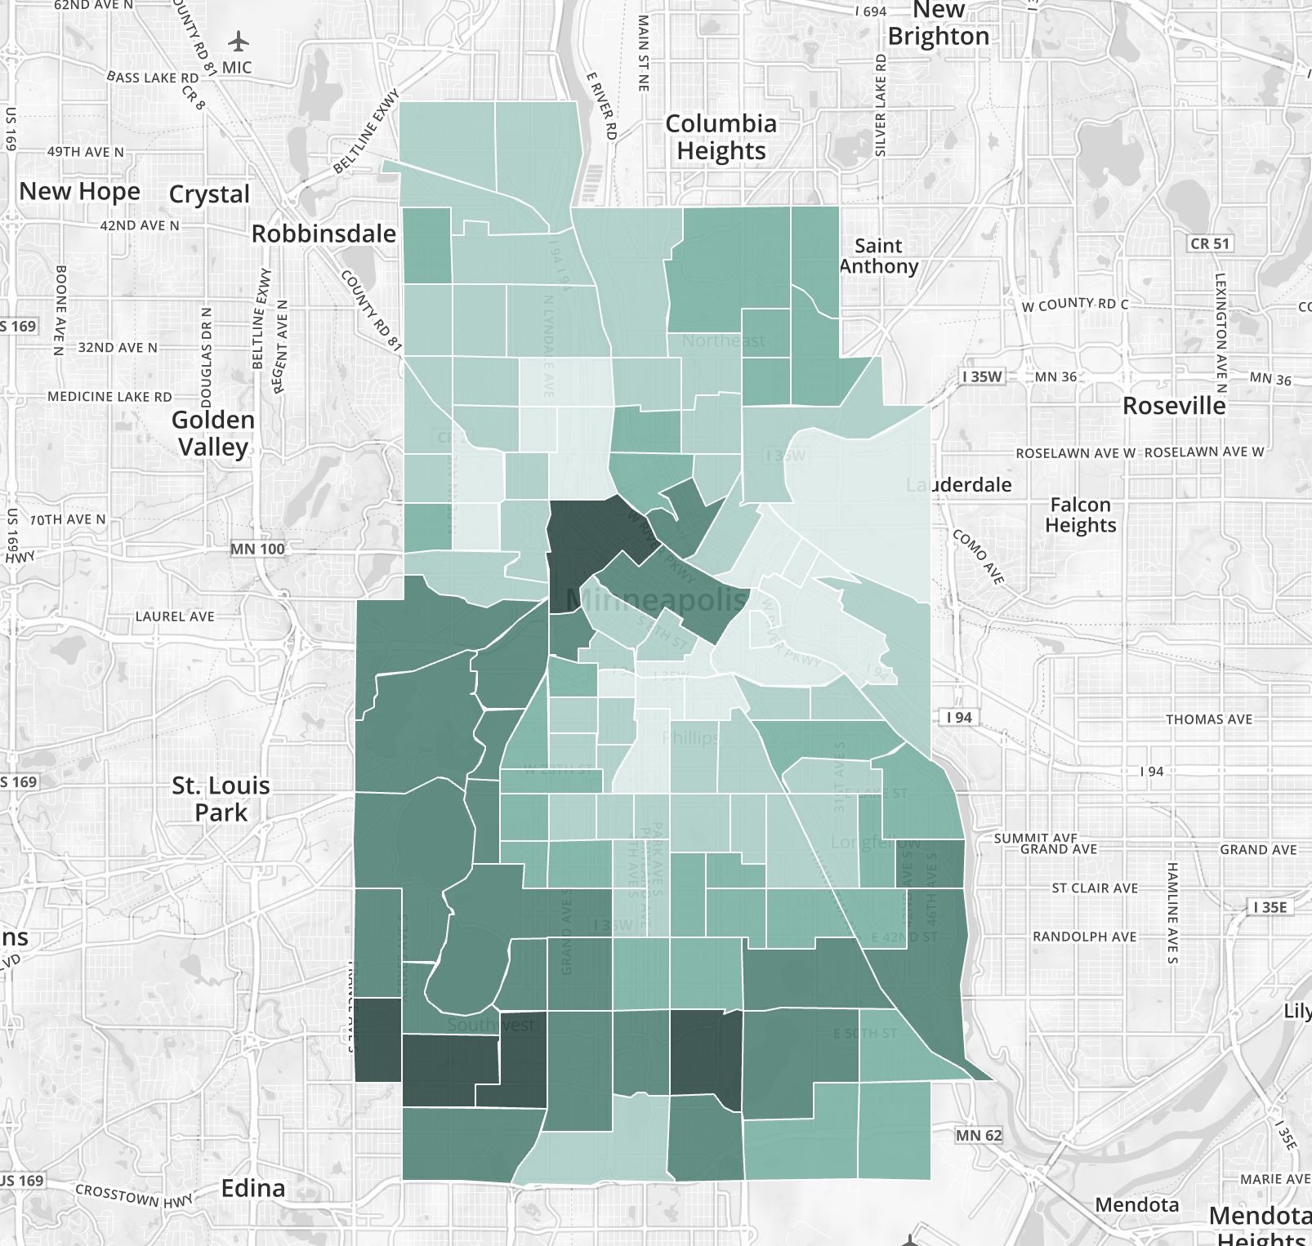**[**EXPLORE THIS**](https://censusreporter.org/data/map/?table=B06011&geo_ids=16000US2743000,140%7C16000US2743000&primary_geo_id=16000US2743000#)

**NON-HISPANIC WHITE POPULATION, 2018**

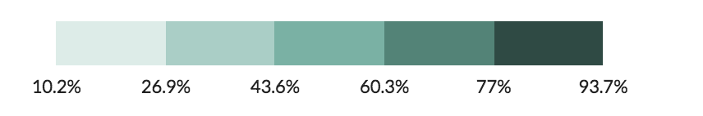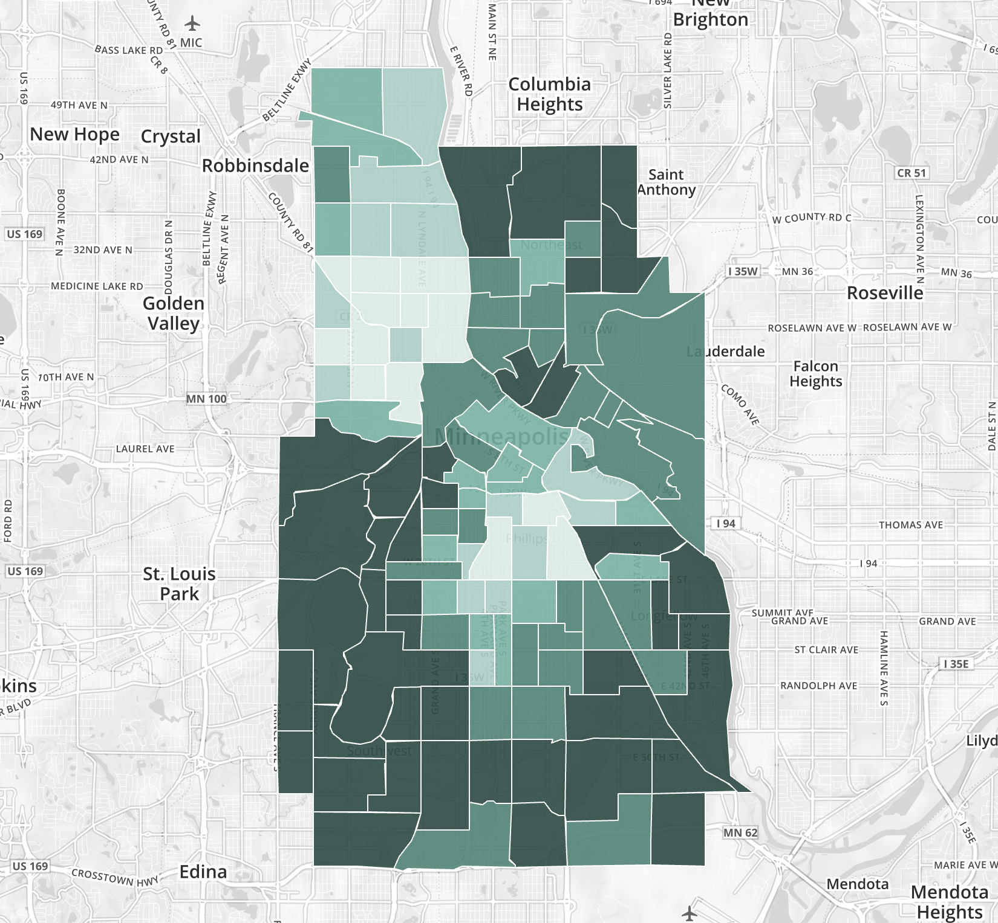

[**EXPLORE THIS**](https://censusreporter.org/data/map/?table=B02001&geo_ids=16000US2743000,140%7C16000US2743000&primary_geo_id=16000US2743000#)

**MEDIAN AGE, 2018**

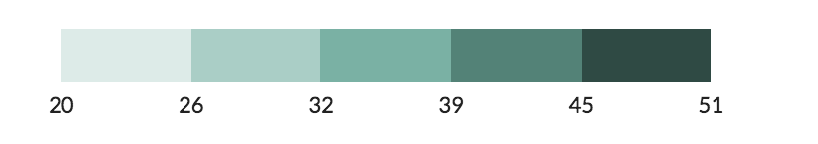

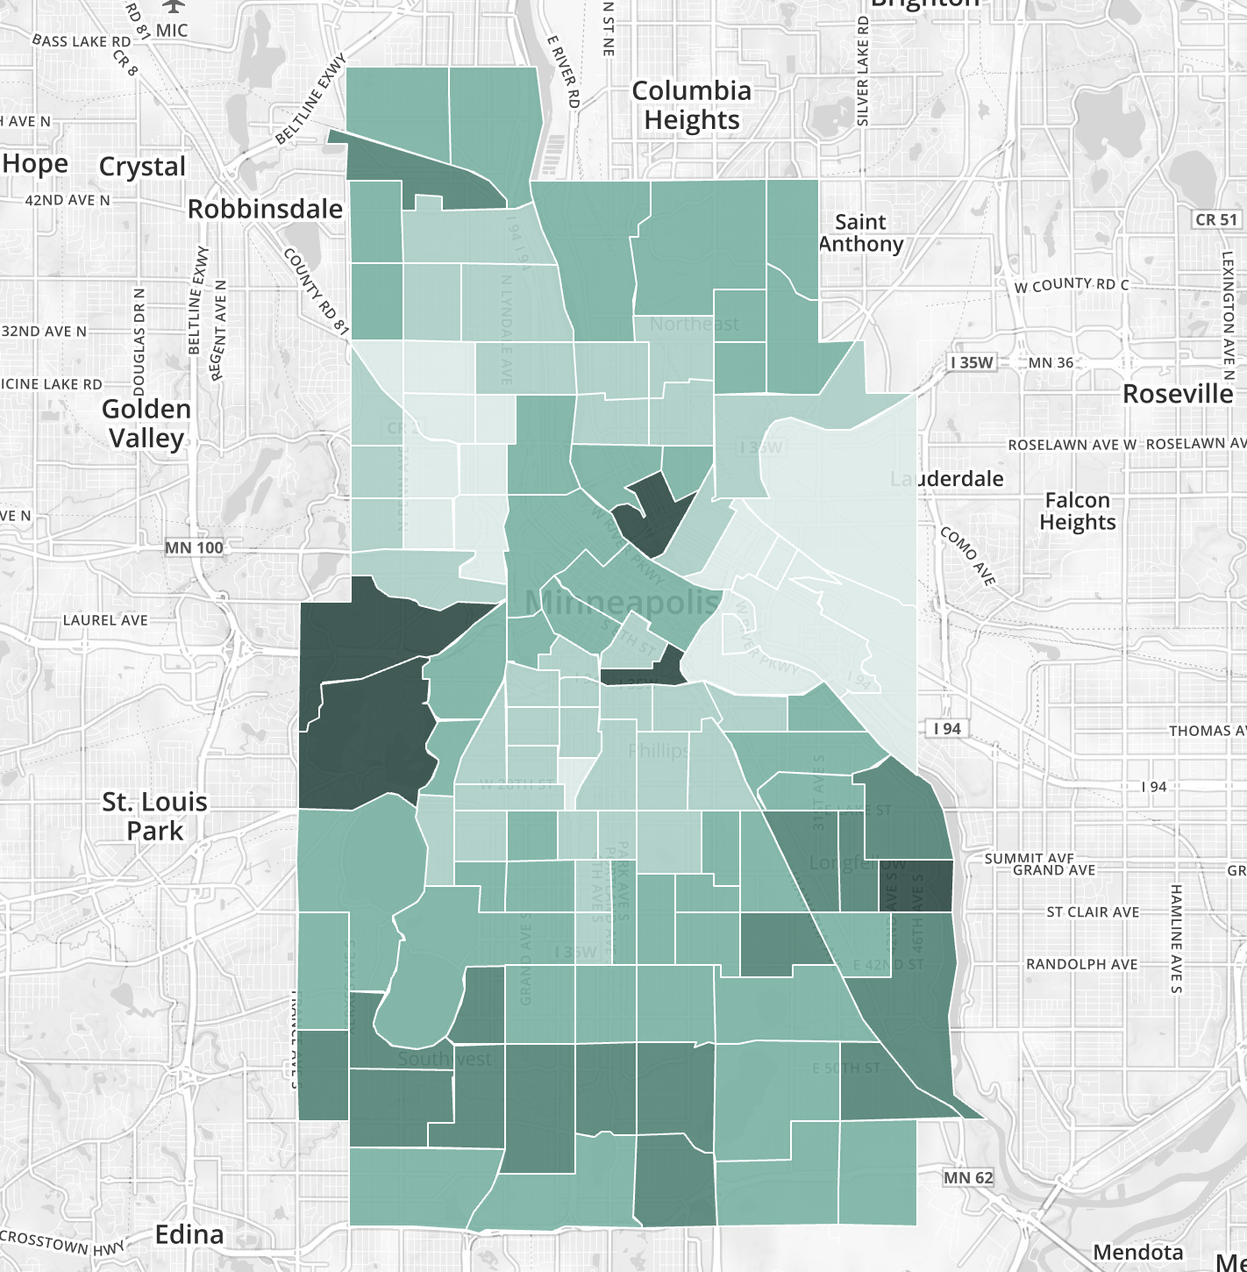

[**EXPLORE THIS**](https://censusreporter.org/data/map/?table=B01002&geo_ids=16000US2743000,140%7C16000US2743000&primary_geo_id=16000US2743000#column%7CB02001002,sumlev%7C140)

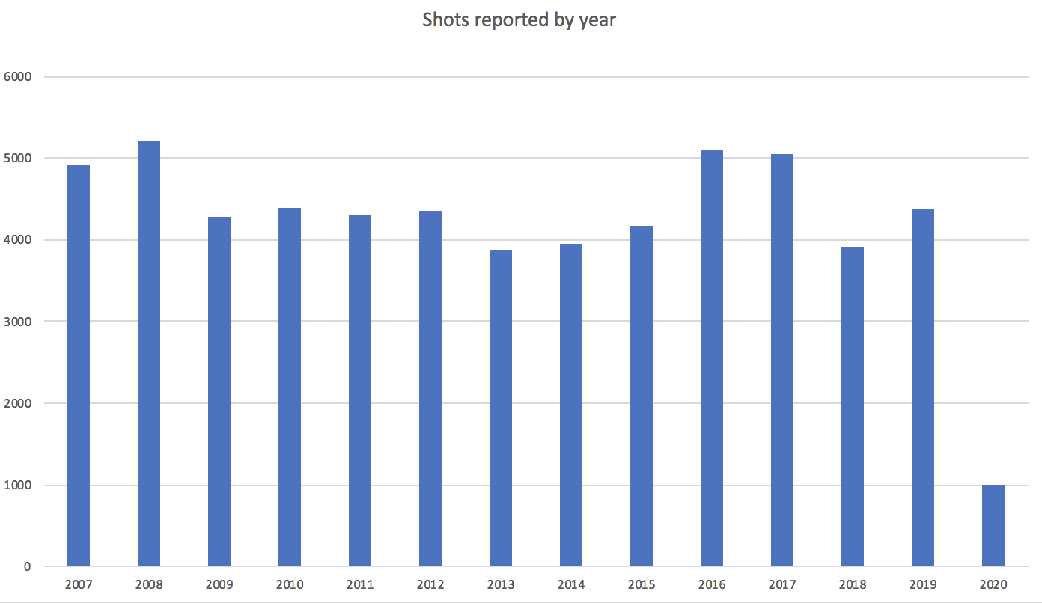

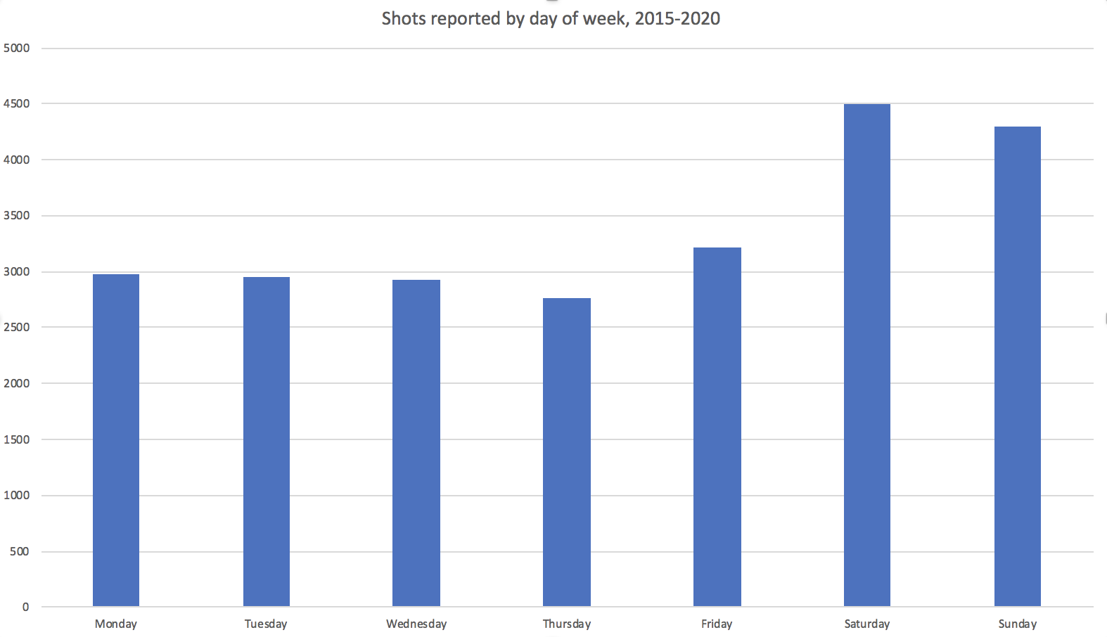

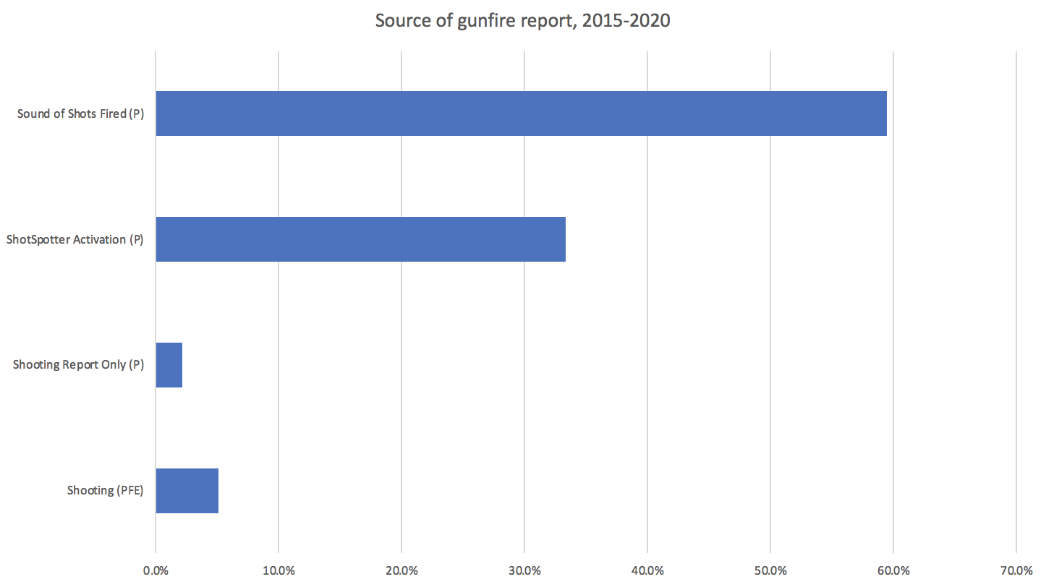

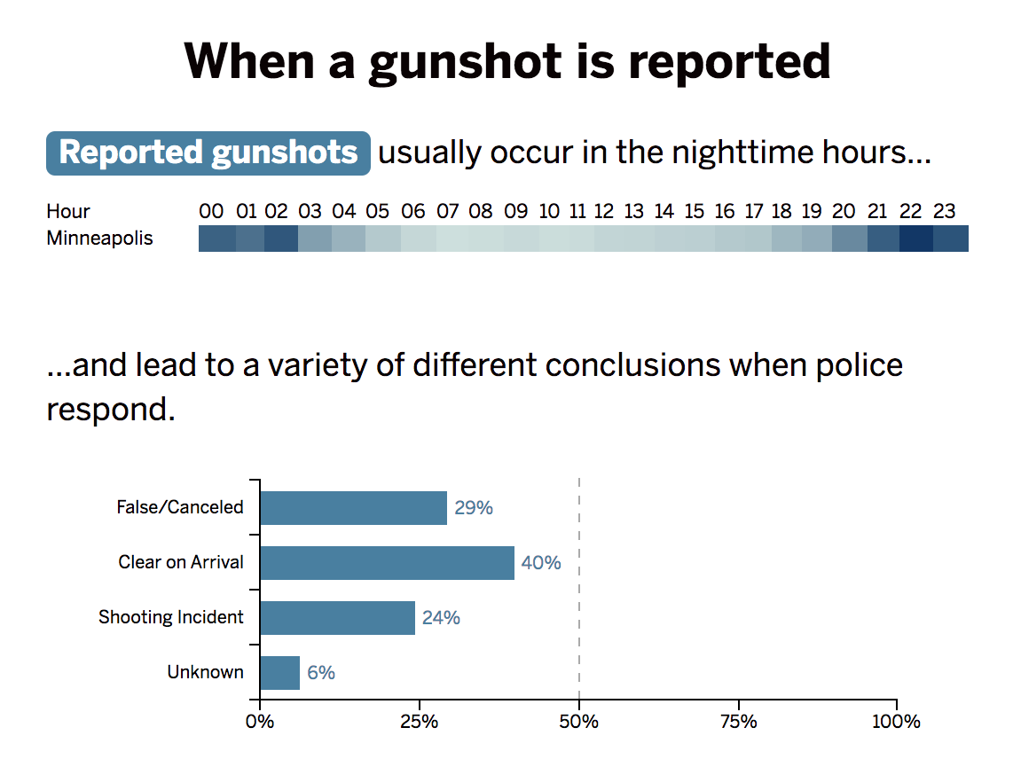

**Dispositions of 1,211 ShotSpotter activations in 2018**

|  |  |  |
| --- | --- | --- |
| AOK- All OK | 190 | 15.7% |
| AQT-All Quiet | 414 | 34.2% |
| CNL-Cancel | 72 | 5.9% |
| FAL-False | 2 | 0.2% |
| FTC-Fail to Clear | 3 | 0.2% |
| GOA-Gone on Arrival | 15 | 1.2% |
| UNF-Unfounded | 68 | 5.6% |
| UTL-Unable to Locate | 42 | 3.5% |
| **NOTHING HAPPENS** | **806** | **66.6%** |
|  |  |  |
| ADV-Advised | 8 | 0.7% |
| AST-Assist | 197 | 16.3% |
| INF-Information | 26 | 2.1% |
| BKG-Booking | 5 | 0.4% |
| INS-Inservice | 6 | 0.5% |
| NOS-No Service | 4 | 0.3% |
| RPT-Report | 96 | 7.9% |
| SEC- Secured | 1 | 0.1% |
| TRN-Transport | 2 | 0.2% |
| **SOMETHING HAPPENS** | **345** | **28.50%** |

**Dispositions of 2,484 non-ShotSpotter gunfire reports in 2018**

|  |  |  |
| --- | --- | --- |
| AOK- All OK | 216 | 8.7% |
| AQT-All Quiet | 548 | 22.1% |
| CNL-Cancel | 755 | 30.4% |
| FAL-False | 1 | 0.0% |
| FTC-Fail to Clear | 3 | 0.1% |
| GOA-Gone on Arrival | 15 | 0.6% |
| UNF-Unfounded | 167 | 6.7% |
| UTL-Unable to Locate | 49 | 2.0% |
| **NOTHING HAPPENS** | **1754** | **70.6%** |
|  |  |  |
| AST-Assist | 282 | 11.4% |
| ADV-Advised | 16 | 0.6% |
| INF-Information | 26 | 1.0% |
| BKG-Booking | 11 | 0.4% |
| INS-Inservice | 14 | 0.6% |
| NOS-No Service | 7 | 0.3% |
| RPT-Report | 194 | 7.8% |
| SNT-Sent | 5 | 0.2% |
| TRN-Transport | 2 | 0.1% |
| **SOMETHING HAPPENS** | **557** | **22.4%** |